|  |
| --- |
| Pipehouse gin limited |
| Business Plan |
| Business Plan for Pipehouse Gin Limited |
|  |
|  |
| **12/1/2017** |

|  |
| --- |
| The business plan for craft gin brand Pipehouse Gin. Covering early stage startup requirements, market analysis and financial projections. |

Contents

Executive Summary 3

Chart: Highlights 3

Objectives 4

1. Mission 4

2. Keys to Success 4

Company 4

Capital resource plan 6

Table: Start-up 6

Chart: Start-up 7

Products 7

The Gin 7

The Bottle 7

Fulfilment 9

Market Analysis 10

Strategy and Implementation 13

Table: Profit and Loss 16

Chart: Profit Monthly 17

Chart: Profit Yearly 17

Chart: Gross Margin Monthly 18

Chart: Gross Margin Yearly 18

Table: Cash Flow 18

Chart: Cash 19

APPENDIX 1

Table: Sales Forecast 1

Table: Profit and Loss 2

Table: Cash Flow 3

Table: Balance Sheet 4

# 

# Executive Summary

Pipehouse Gin is a boutique craft gin company created by four gin-loving friends located in Tunbridge Wells. What differentiates it is that Pipehouse Gin is built using very modern business principles. Every part of the business logistics will be outsourced, including both the distilling of the gin and the fulfilment of customer orders, leaving the founders to focus on marketing and business development.

In this business plan we lay out exactly what it will take to start Pipehouse Gin and bring the first product to market. We then also present a detailed market analysis and very profitable but also conservative sales forecast.

Our founding team is very experienced in building this type of business and has considerable followings who have expressed interest in buying the gin. When combined with the low minimum orders needed by our distilling partners, and the zero debt the business is taking on, there is a very low likelihood of failure.

### Chart: Highlights

ooxWord://word/media/image1.emf

## 

# Objectives

### 1. Mission

Pipehouse Gin was started because we witnessed a large gap in the market that we believe we are perfectly positioned to fill. We are lucky that this gap in the market also intersects with one of our passions. Gin has become more and more popular over the last couple of years and trend analysis indicates that this trend is going to continue.

There are quite a few gin producers on the market, but we have noticed a dearth of flavoured gin. On top of this, gin is primarily sold through distribution networks and to bars. Due to our extensive experience in online sales and marketing we are confident that we will be perfectly placed at the forefront of direct-to-consumer online sales – a market that is only going to grow.

### 2. Keys to Success

1. Strong brand.
2. Well designed website.
3. Strategic partnerships with local bars to give us a strong legitimacy among gin drinkers.
4. High ranking on Google for searches relating to flavoured gin in the UK.
5. Strong supply chain with robust built-in margins.

# Company

Pipehouse Gin Limited is a private limited company incorporated in England and Wales with the number 11072810. It is owned 25% each by Ben Larcombe, Katherine Larcombe, Sam Priestley, and Emma Priestley.

Each owner brings a different skill set to the table:

* Katherine Larcombe - A skilled artist and graphic designer whose primary business has been her art since 2014. She has an excellent eye for detail and is in-charge of everything branding and design related.
* Emma Priestley - A professional marketer who has been running her own marketing firm for the last year. Previous to which she was a marketing manager at PwC. She is in charge of all business relationships and offline marketing.
* Samuel Priestley & Ben Larcombe - Both own a table tennis equipment business, which they built from scratch and now is the best-selling table tennis equipment business in the UK. This is primarily because of their direct-to-consumer strategy which they are planning to bring to the Pipehouse Gin Limited. They are both responsible for online marketing and supply chain management.

There will be no staff employed by Pipehouse Gin.

All four have a deep in-depth knowledge of and passion for gin.

#### Branding

The company is called Pipehouse Gin and that is our brand name. But our requirements were that it must:

* Sound and feel high-end.
* Represent Tunbridge Wells.

We chose the word Pipehouse for a variety of reasons:

* The Pipe House was the first drinking establishment in Tunbridge Wells and was located very close to where our house is now. So there is a local story behind it.
* Copper pipes are cool, and there is a lot we can do with the design. Think copper pipes coming out of a copper gin still with all the different botanicals growing out of them.
* It’s memorable. When you see the copper pipes and maybe a house on the label it adds an image that will stick in your head. Whereas a brand named after a person is much harder to remember.
* It looks good written down. In the words of our designer Katherine Larcombe, the artist on team gin: “I don’t object to any of the letters”.

Start-up Summary

### Capital resource plan

The directors will invest the required start-up capital.

Due to the nature of the business the main risk to the start-up capital is if we struggle to sell the initial stock and need to pay ongoing storage fees. But seeing as we have negotiated a very small minimum order quantity we can scale up slowly and mitigate this risk.

We have also built in a very large buffer of cash holding (£5,000). This will cover the cost of storing our initial order for many years.

There will be no need for loans during the start-up phase so the company will not be taking on debt.

### Table: Start-up

|  |  |
| --- | --- |
| *Start-up* |  |
|  |  |
| Requirements |  |
|  |  |
| Start-up Expenses |  |
| Legal & Accountancy | £1,000 |
| Insurance | £250 |
| Product Development | £1,000 |
| Design Work | £500 |
| Samples | £250 |
| Other | £200 |
| Total Start-up Expenses | £3,200 |
|  |  |
| Start-up Assets |  |
| Cash Required | £5,000 |
| Start-up Stock | £4,500 |
| Total Assets | £9,500 |
|  |  |
| **Total Requirements** | £12,700 |

### Chart: Start-up

ooxWord://word/media/image2.emf

# Products

Pipehouse Gin Limited sells its own exclusive recipe flavoured low-sugar gin.

### The Gin

The first flavour that we will be selling is Earl Grey & Cucumber. The recipe has already been created at a cost of just under £750 (we still have a contingency for another £250 incase more work is needed).

Once the initial recipe was developed we focus group tested six variants to find the best one.

To mass produce the gin we have teamed up with an award winning small-batch distillery. They have agreed to create our gin to our specified recipe exclusive to Pipehouse Gin Limited. They are able to create batches of our gin at a quantity of 250 per batch. This is a very small minimum order in the industry and will allow us to expand safely but also rapidly.

### 

### The Bottle

The bottle and label are being sourced separately. The bottle is a standard bottle and we are currently trying samples from different suppliers. Our preferred shapes are below:

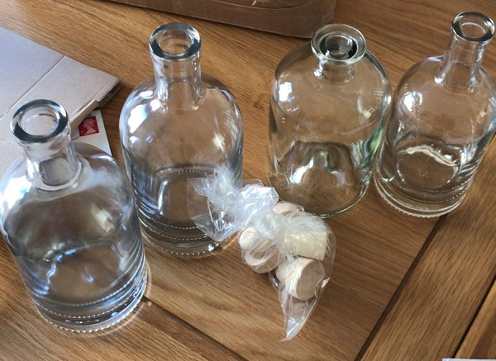

They come with real cork stoppers which is our preference.

#### The Label

The label will be designed by Katherine Larcombe with the help of some outsourced designers. Here are some mockups of our early label ideas:

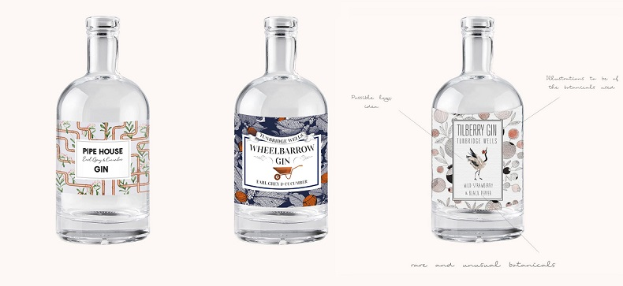

#### Future Products

We plan to launch more flavours of gin. The low cost of development and small minimum order quantity gives us a lot of flexibility in trying new products.

Some flavours we plan to try:

* Wild Strawberry & Black Pepper
* Pink Grapefruit & Sage
* Blood Orange & Dark Ginger
* Plum & Thyme
* Rose & Cardamom

Once we have a few flavours available we can launch multi-packs of smaller amounts (50ml each). So that customers can try one of each of our gins.

# Fulfilment

We have the choice between partnering with a bonded warehouse or with a normal warehouse that has the appropriate licenses to fulfil alcohol orders.

If we decide to partner with a bonded warehouse we will need a ‘Warehousekeeper or Owner of Warehoused Goods Registration’ license which we plan to apply for.

We have had many quotes and expressions of interest. Below are our preferences:

**Excise Bonded Warehouse**

|  |  |  |
| --- | --- | --- |
| **Johnston Logisitics** |  |  |
|  | **Cost** | **How frequent?** |
| **Lisence Contribution** |  |  |
| **Storage** | £170 | per pallet per month |
| **Goods in** | £2.70 | per bottle |
| **Pick and pack** | 30p | per bottle |
| **Delivery** |  | DPD Courier |
| **Packaging** | £1 | per bottle |

**Normal Warehouse With Alcohol License**

|  |  |  |
| --- | --- | --- |
| **Mosaic Fulfilments Solutions** |  |  |
|  | **Cost** | **How frequent?** |
| **Storage** | £8.50 | per month and per palette |
| **Goods in** | £3.5 | per palette |
| **Pick and pack** | £1.20 |  |
| **Delivery** | £3 |  |
| **Packaging** | 5p - £2 |  |
| **Management fee** | £300 per month |  |

# Market Analysis

#### Market Segmentation

**1. Direct To Consumer Online Sales**

Online sales are a fast growing market over all retail, and in particular in alcohol sales. Our market research shows that there are over 360,000 sales of gin a year just on Amazon.co.uk! Due to our extensive experience selling physical products online (including Amazon) we expect to be able to take a large chunk of these sales.

**2. Direct To Consumer Offline Sales (market stalls etc)**

Tunbridge Wells is a affluent town which prides itself on supporting local businesses. There are regular markets held each week throughout the year, along with a large amount of one-off events focused around food and drink. From speaking to another gin brand in a similar market space, sales of their gin from these events are often in the region of 50+ bottles. By playing on our gin being created in Tunbridge Wells we hope to tap into this 'local' market.

**3. Wholesale To Distribution Companies**

We do not have a lot of experience with distribution companies, and we do not plan for this to be a large part of our sales. That may change in the future.

**4. Wholesale To Local Businesses**

Located in Tunbridge Wells are two gin bars, along with 15-20 other speciality pubs and bars. There is also a large collection of farm shops and specialist food boutiques. We have already received expressions of interest from some of these businesses, including offers of advice and support. Local businesses in Tunbridge Wells have shown a consistent desire to support us.

#### Industry Analysis

Gin has become more and more popular over the last couple of years and in particular in the last six months. Below is the Google search trend data from gin vs vodka. As you can see, up until the beginning of 2016 vodka was more popular than gin in the UK. But since then Gin has completely shot away and is now receiving 4 times as many searches as vodka.

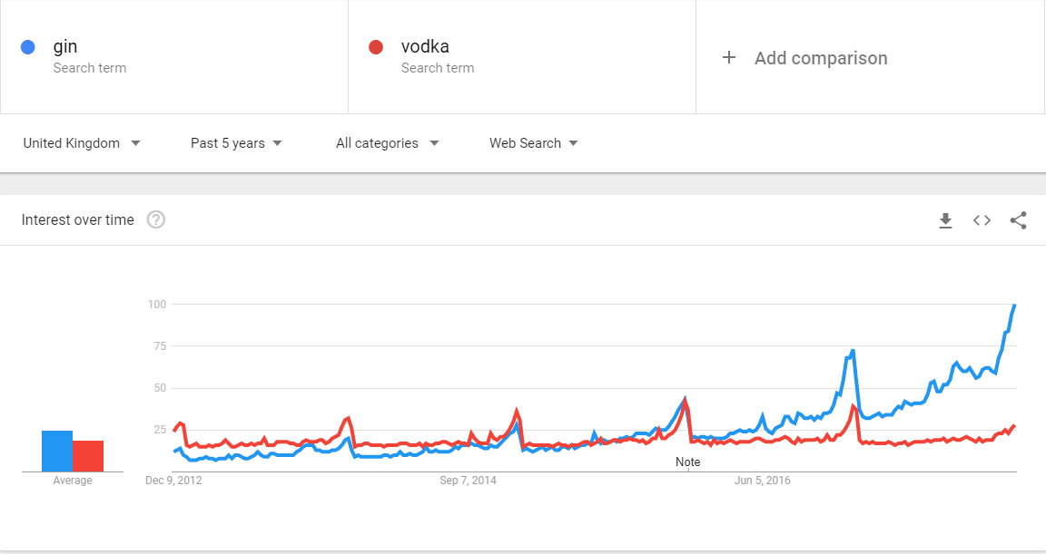

A more in-depth analysis on the Amazon online marketplace (the biggest e-commerce website) shows us roughly the current sales volume of gin.

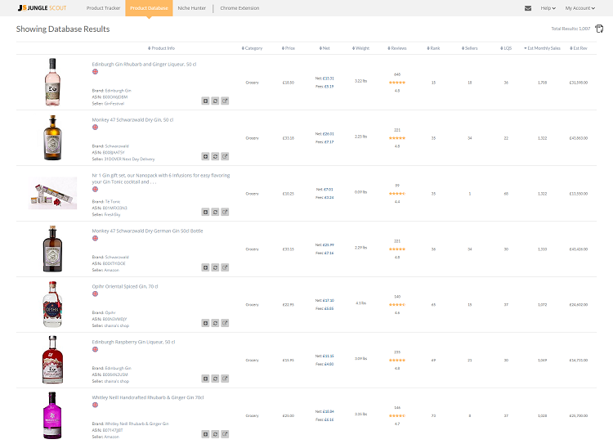

The top 40 gins on Amazon are each selling over 1,000 bottles a month.

Looking more deeply into Amazon search trends we can see:

* The gins with the highest monthly revenue are selling for between £29 and £35 a bottle. There is a good profit margin to be made there.
* 40 of the gins are each earning over £10k per month in revenue. Just on Amazon.
* A lot of the gins are 50cl rather than the usual 70cl - and still selling for over £30. If we could do a 50cl bottle as well that would bring all our costs right down.
* Flavoured gins seem to be the most popular. "Rhubarb", "Ginger", "Raspberry", "Plum" are all selling well.

**Flavoured Gins**

The top 4 bestselling gins in both of Tunbridge Well's boutique gin bars are all flavoured gins. This is less prominent online, but even there half of the top 20 bestselling gins are flavoured. When only 10% of the gins available on the market are flavoured this leaves a large potential market.

#### Competition and Buying Patterns

Although there is a lot of standard or 'London Dry' gins on the market. There are relatively few flavoured ones. Our main competitors are:

**Whitley Neil's Rhubarb & Ginger Gin**

This is the best-selling gin at Chapel Place (the premier gin bar in Tunbridge Wells). It also does very well online and on Amazon. Our product is very different from it, in 1) we do not share any common flavours, 2) it is a lot sweeter with added sugar. More of a liquor than a gin.

**Hendricks' Cucumber Flavoured Gin**

Hendricks is a big established brand in the gin market. It also shares one of our primary flavours, cucumber. But we are targeting very different markets. Hendricks is a household name gin from a big corporation. We are targeting a more artisan market who appreciate craft gins. That market will purposely not buy big brand gins like Hendricks.

**Bathtub Gin**

Bathtub Gin is a local gin to Tunbridge Wells and is a brand that has been winning many awards and has become hugely popular. But it is not a flavoured gin, and we believe there is still plenty of room in the local market for a new gin. Especially as Bathtub Gin has now grown so large that they no longer bother with local markets or trying to market themselves locally.

# Strategy and Implementation

#### Marketing Strategy

* Approach local bars and food boutiques.
* Create an elegant and appealing website.
* Use search engine optimisation expertise from the directors to rank highly on search engines.
* Launch a social media campaign.
* Provide excellent customer service online and request reviews from customers.
* Contact local markets to set up a stall.
* Contact local news magazines and papers to get featured.

#### Sales Strategy

Our first batch is only 250 bottles. The selling of which will be fairly straight forward:

1. **Friends & Family**: We have a lot of interest from friends and family
2. **Local Bars:** Local Gin bars have expressed that they would like to buy some of our initial batch.
3. **Online Followers**: Sam Priestley has a very popular blog (sampriestley.com) where he has been talking about his plans to set up a brand of gin. There have been over 50 expressions of interest from people saying they will buy a bottle when it is ready.
4. **Amazon** : Sam Priestley & Ben Larcombe currently sell around 1,500 table tennis bats a month on Amazon. The market for gin is much higher than that so they will use their expertise to gain sales from there.

Once we have sold the majority of our first batch we will look at where we are getting sales from and in what velocity and focus on those avenues.

#### Sales Forecast

We have started off with some conservative estimates.

1. We expect to sell out of our initial 250 units by the end of the second month.
2. We expect steady growth for the first year.
3. We expect Christmas to be a period of much higher sales.
4. We expect to launch at least two new gins in the first 12 months.
5. Our outsourced distiller is currently expanding their capacity and will be able to fulfill our sales projections.
6. At no point in the first three years will our sales be high enough to place us in the top 50 bestselling list of gins on Amazon. Therefore there is still plenty of expansion possible.

**Unit Costs**

Here is a more detailed breakdown of our unit costs:

* Gin - £4
* Bottle - £1
* Label - £1
* VAT - £1.2
* Duty - £7.8
* Pick & Pack - £3
* Packaging - £1
* Shipping - £3.5
* Sales Cost (processing fees) - £6.6

#### Table: Sales Forecast

|  |  |  |  |
| --- | --- | --- | --- |
| *Sales Forecast* |  |  |  |
|  | 2018 | 2019 | 2020 |
| Unit Sales |  |  |  |
| Earl Grey & Cucumber Gin | 5,800 | 7,500 | 12,000 |
| Gin Flavour 2 | 3,275 | 4,500 | 7,500 |
| Gin Flavour 3 | 1,825 | 2,500 | 3,500 |
| Sample Set | 1,780 | 3,000 | 6,000 |
| Total Unit Sales | 12,680 | 17,500 | 29,000 |
|  |  |  |  |
| Unit Prices | 2018 | 2019 | 2020 |
| Earl Grey & Cucumber Gin | £39.99 | £39.99 | £39.99 |
| Gin Flavour 2 | £39.99 | £39.99 | £39.99 |
| Gin Flavour 3 | £39.99 | £39.99 | £39.99 |
| Sample Set | £15.00 | £15.00 | £15.00 |
|  |  |  |  |
| Sales |  |  |  |
| Earl Grey & Cucumber Gin | £231,942 | £299,925 | £479,880 |
| Gin Flavour 2 | £130,967 | £179,955 | £299,925 |
| Gin Flavour 3 | £72,982 | £99,975 | £139,965 |
| Sample Set | £26,700 | £45,000 | £90,000 |
| Total Sales | £462,591 | £624,855 | £1,009,770 |
|  |  |  |  |
| Direct Unit Costs | 2018 | 2019 | 2020 |
| Earl Grey & Cucumber Gin | £24.99 | £24.99 | £24.99 |
| Gin Flavour 2 | £24.99 | £24.99 | £24.99 |
| Gin Flavour 3 | £24.99 | £24.99 | £24.99 |
| Sample Set | £7.50 | £7.50 | £7.50 |
|  |  |  |  |
| Direct Cost of Sales |  |  |  |
| Earl Grey & Cucumber Gin | £144,964 | £187,453 | £299,925 |
| Gin Flavour 2 | £81,855 | £112,472 | £187,453 |
| Gin Flavour 3 | £45,614 | £62,484 | £87,478 |
| Sample Set | £13,350 | £22,500 | £45,000 |
| **Subtotal Direct Cost of Sales** | £285,782 | £384,909 | £619,856 |

#### Chart: Sales Monthly

ooxWord://word/media/image8.emf

#### Chart: Sales by Year

ooxWord://word/media/image9.emf

#### Financials

#### Projected Profit & Loss

### Table: Profit and Loss

|  |  |  |  |
| --- | --- | --- | --- |
| *Pro Forma Profit and Loss* |  |  |  |
|  | 2018 | 2019 | 2020 |
| Sales | £462,591 | £624,855 | £1,009,770 |
| Direct Cost of Sales | £285,782 | £384,909 | £619,856 |
| Other Costs of Sales | £13,922 | £26,000 | £39,000 |
| Total Cost of Sales | £299,704 | £410,909 | £658,856 |
|  |  |  |  |
| Gross Margin | £162,887 | £213,946 | £350,914 |
| Gross Margin % | 35.21% | 34.24% | 34.75% |
|  |  |  |  |
|  |  |  |  |
| Expenses |  |  |  |
| Marketing/Promotion | £5,112 | £12,000 | £24,000 |
| Insurance | £300 | £350 | £500 |
|  |  |  |  |
| Total Operating Expenses | £5,412 | £12,350 | £24,500 |
|  |  |  |  |
| Profit Before Interest and Taxes | £157,475 | £201,596 | £326,414 |
| EBITDA | £157,475 | £201,596 | £326,414 |
| Taxes Incurred | £31,495 | £40,319 | £65,283 |
|  |  |  |  |
| Net Profit | £125,980 | £161,276 | £261,131 |
| **Net Profit/Sales** | 27.23% | 25.81% | 25.86% |

### Chart: Profit Monthly

ooxWord://word/media/image12.emf

### Chart: Profit Yearly

ooxWord://word/media/image13.emf

### Chart: Gross Margin Monthly

ooxWord://word/media/image14.emf

### Chart: Gross Margin Yearly

ooxWord://word/media/image15.emf

#### Projected Cash Flow

We do not plan to take money out of the business until we have built up a decent cash balance.

### Table: Cash Flow

|  |  |  |  |
| --- | --- | --- | --- |
| *Pro Forma Cash Flow* |  |  |  |
|  | 2018 | 2019 | 2020 |
| Cash Received |  |  |  |
|  |  |  |  |
| Cash from Operations |  |  |  |
| Cash Sales | £462,591 | £624,855 | £1,009,770 |
| Subtotal Cash from Operations | £462,591 | £624,855 | £1,009,770 |
|  |  |  |  |
| Additional Cash Received |  |  |  |
| VAT Received (Output Tax) | £92,518 | £124,971 | £201,954 |
| Subtotal Cash Received | £555,458 | £749,826 | £1,211,724 |
|  |  |  |  |
| Expenditures | 2018 | 2019 | 2020 |
|  |  |  |  |
| Expenditures from Operations |  |  |  |
| Bill Payments | £418,909 | £446,724 | £811,012 |
| Subtotal Spent on Operations | £418,909 | £446,724 | £811,012 |
|  |  |  |  |
| Additional Cash Spent |  |  |  |
| VAT Paid Out (Input Tax) | £90,016 | £72,039 | £152,664 |
| VAT Payments | £1,839 | £53,943 | £49,290 |
| Subtotal Cash Spent | £510,765 | £572,706 | £1,012,966 |
|  |  |  |  |
| Net Cash Flow | £44,693 | £177,120 | £198,758 |
| **Cash Balance** | £49,693 | £226,813 | £425,571 |

### Chart: Cash

ooxWord://word/media/image16.emf

# APPENDIX

### Table: Sales Forecast

|  |  |  |  |  |  |  |  |  |  |  |  |  |  |
| --- | --- | --- | --- | --- | --- | --- | --- | --- | --- | --- | --- | --- | --- |
| *Sales Forecast* |  |  |  |  |  |  |  |  |  |  |  |  |  |
|  |  | Jan | Feb | Mar | Apr | May | Jun | Jul | Aug | Sep | Oct | Nov | Dec |
| Unit Sales |  |  |  |  |  |  |  |  |  |  |  |  |  |
| Earl Grey & Cucumber Gin | 0% | 150 | 100 | 150 | 200 | 250 | 300 | 350 | 450 | 600 | 750 | 1,000 | 1,500 |
| Gin Flavour 2 | 0% | 0 | 0 | 0 | 150 | 200 | 250 | 275 | 300 | 350 | 450 | 550 | 750 |
| Gin Flavour 3 | 0% | 0 | 0 | 0 | 0 | 0 | 0 | 150 | 200 | 250 | 325 | 400 | 500 |
| Sample Set | 0% | 0 | 0 | 0 | 0 | 0 | 0 | 100 | 120 | 160 | 200 | 400 | 800 |
| Total Unit Sales |  | 150 | 100 | 150 | 350 | 450 | 550 | 875 | 1,070 | 1,360 | 1,725 | 2,350 | 3,550 |
|  |  |  |  |  |  |  |  |  |  |  |  |  |  |
| Unit Prices |  | Jan | Feb | Mar | Apr | May | Jun | Jul | Aug | Sep | Oct | Nov | Dec |
| Earl Grey & Cucumber Gin |  | £39.99 | £39.99 | £39.99 | £39.99 | £39.99 | £39.99 | £39.99 | £39.99 | £39.99 | £39.99 | £39.99 | £39.99 |
| Gin Flavour 2 |  | £39.99 | £39.99 | £39.99 | £39.99 | £39.99 | £39.99 | £39.99 | £39.99 | £39.99 | £39.99 | £39.99 | £39.99 |
| Gin Flavour 3 |  | £39.99 | £39.99 | £39.99 | £39.99 | £39.99 | £39.99 | £39.99 | £39.99 | £39.99 | £39.99 | £39.99 | £39.99 |
| Sample Set |  | £15.00 | £15.00 | £15.00 | £15.00 | £15.00 | £15.00 | £15.00 | £15.00 | £15.00 | £15.00 | £15.00 | £15.00 |
|  |  |  |  |  |  |  |  |  |  |  |  |  |  |
| Sales | VAT Rate |  |  |  |  |  |  |  |  |  |  |  |  |
| Earl Grey & Cucumber Gin | 20.00% | £5,999 | £3,999 | £5,999 | £7,998 | £9,998 | £11,997 | £13,997 | £17,996 | £23,994 | £29,993 | £39,990 | £59,985 |
| Gin Flavour 2 | 20.00% | £0 | £0 | £0 | £5,999 | £7,998 | £9,998 | £10,997 | £11,997 | £13,997 | £17,996 | £21,995 | £29,993 |
| Gin Flavour 3 | 20.00% | £0 | £0 | £0 | £0 | £0 | £0 | £5,999 | £7,998 | £9,998 | £12,997 | £15,996 | £19,995 |
| Sample Set | 20.00% | £0 | £0 | £0 | £0 | £0 | £0 | £1,500 | £1,800 | £2,400 | £3,000 | £6,000 | £12,000 |
| Total Sales |  | £5,999 | £3,999 | £5,999 | £13,997 | £17,996 | £21,995 | £32,492 | £39,791 | £50,388 | £63,985 | £83,981 | £121,973 |
|  |  |  |  |  |  |  |  |  |  |  |  |  |  |
| Direct Unit Costs |  | Jan | Feb | Mar | Apr | May | Jun | Jul | Aug | Sep | Oct | Nov | Dec |
| Earl Grey & Cucumber Gin | 62.50% | £24.99 | £24.99 | £24.99 | £24.99 | £24.99 | £24.99 | £24.99 | £24.99 | £24.99 | £24.99 | £24.99 | £24.99 |
| Gin Flavour 2 | 62.50% | £24.99 | £24.99 | £24.99 | £24.99 | £24.99 | £24.99 | £24.99 | £24.99 | £24.99 | £24.99 | £24.99 | £24.99 |
| Gin Flavour 3 | 62.50% | £24.99 | £24.99 | £24.99 | £24.99 | £24.99 | £24.99 | £24.99 | £24.99 | £24.99 | £24.99 | £24.99 | £24.99 |
| Sample Set | 50.00% | £7.50 | £7.50 | £7.50 | £7.50 | £7.50 | £7.50 | £7.50 | £7.50 | £7.50 | £7.50 | £7.50 | £7.50 |
|  |  |  |  |  |  |  |  |  |  |  |  |  |  |
| Direct Cost of Sales | VAT Rate |  |  |  |  |  |  |  |  |  |  |  |  |
| Earl Grey & Cucumber Gin | 20.00% | £3,749 | £2,499 | £3,749 | £4,999 | £6,248 | £7,498 | £8,748 | £11,247 | £14,996 | £18,745 | £24,994 | £37,491 |
| Gin Flavour 2 | 20.00% | £0 | £0 | £0 | £3,749 | £4,999 | £6,248 | £6,873 | £7,498 | £8,748 | £11,247 | £13,747 | £18,745 |
| Gin Flavour 3 | 20.00% | £0 | £0 | £0 | £0 | £0 | £0 | £3,749 | £4,999 | £6,248 | £8,123 | £9,998 | £12,497 |
| Sample Set | 20.00% | £0 | £0 | £0 | £0 | £0 | £0 | £750 | £900 | £1,200 | £1,500 | £3,000 | £6,000 |
| **Subtotal Direct Cost of Sales** |  | £3,749 | £2,499 | £3,749 | £8,748 | £11,247 | £13,747 | £20,120 | £24,644 | £31,193 | £39,615 | £51,738 | £74,733 |

# 

### Table: Profit and Loss

|  |  |  |  |  |  |  |  |  |  |  |  |  |  |
| --- | --- | --- | --- | --- | --- | --- | --- | --- | --- | --- | --- | --- | --- |
| *Pro Forma Profit and Loss* |  |  |  |  |  |  |  |  |  |  |  |  |  |
|  |  | Jan | Feb | Mar | Apr | May | Jun | Jul | Aug | Sep | Oct | Nov | Dec |
| Sales | VAT Rate | £5,999 | £3,999 | £5,999 | £13,997 | £17,996 | £21,995 | £32,492 | £39,791 | £50,388 | £63,985 | £83,981 | £121,973 |
| Direct Cost of Sales |  | £3,749 | £2,499 | £3,749 | £8,748 | £11,247 | £13,747 | £20,120 | £24,644 | £31,193 | £39,615 | £51,738 | £74,733 |
| Other Costs of Sales | 20.00% | £100 | £140 | £196 | £274 | £384 | £538 | £753 | £1,054 | £1,476 | £2,066 | £2,892 | £4,049 |
| Total Cost of Sales |  | £3,849 | £2,639 | £3,945 | £9,022 | £11,631 | £14,285 | £20,873 | £25,698 | £32,669 | £41,681 | £54,630 | £78,782 |
|  |  |  |  |  |  |  |  |  |  |  |  |  |  |
| Gross Margin |  | £2,149 | £1,360 | £2,053 | £4,975 | £6,364 | £7,710 | £11,619 | £14,092 | £17,720 | £22,303 | £29,351 | £43,191 |
| Gross Margin % |  | 35.83% | 34.00% | 34.23% | 35.54% | 35.37% | 35.05% | 35.76% | 35.42% | 35.17% | 34.86% | 34.95% | 35.41% |
|  |  |  |  |  |  |  |  |  |  |  |  |  |  |
|  |  |  |  |  |  |  |  |  |  |  |  |  |  |
| Expenses | VAT Rate |  |  |  |  |  |  |  |  |  |  |  |  |
| Marketing/Promotion | 20.00% | £100 | £124 | £154 | £191 | £237 | £294 | £365 | £453 | £562 | £697 | £864 | £1,071 |
| Insurance | 20.00% | £25 | £25 | £25 | £25 | £25 | £25 | £25 | £25 | £25 | £25 | £25 | £25 |
|  |  |  |  |  |  |  |  |  |  |  |  |  |  |
| Total Operating Expenses | VAT Rate | £125 | £149 | £179 | £216 | £262 | £319 | £390 | £478 | £587 | £722 | £889 | £1,096 |
|  |  |  |  |  |  |  |  |  |  |  |  |  |  |
| Profit Before Interest and Taxes |  | £2,024 | £1,211 | £1,874 | £4,759 | £6,102 | £7,391 | £11,229 | £13,614 | £17,133 | £21,581 | £28,462 | £42,095 |
| EBITDA |  | £2,024 | £1,211 | £1,874 | £4,759 | £6,102 | £7,391 | £11,229 | £13,614 | £17,133 | £21,581 | £28,462 | £42,095 |
| Taxes Incurred |  | £405 | £242 | £375 | £952 | £1,220 | £1,478 | £2,246 | £2,723 | £3,427 | £4,316 | £5,692 | £8,419 |
|  |  |  |  |  |  |  |  |  |  |  |  |  |  |
| Net Profit |  | £1,620 | £969 | £1,500 | £3,807 | £4,882 | £5,913 | £8,983 | £10,892 | £13,706 | £17,265 | £22,769 | £33,676 |
| **Net Profit/Sales** |  | 27.00% | 24.22% | 25.00% | 27.20% | 27.13% | 26.88% | 27.65% | 27.37% | 27.20% | 26.98% | 27.11% | 27.61% |

### Table: Cash Flow

|  |  |  |  |  |  |  |  |  |  |  |  |  |  |
| --- | --- | --- | --- | --- | --- | --- | --- | --- | --- | --- | --- | --- | --- |
| *Pro Forma Cash Flow* |  |  |  |  |  |  |  |  |  |  |  |  |  |
|  |  | Jan | Feb | Mar | Apr | May | Jun | Jul | Aug | Sep | Oct | Nov | Dec |
| Cash Received |  |  |  |  |  |  |  |  |  |  |  |  |  |
|  |  |  |  |  |  |  |  |  |  |  |  |  |  |
| Cash from Operations |  |  |  |  |  |  |  |  |  |  |  |  |  |
| Cash Sales |  | £5,999 | £3,999 | £5,999 | £13,997 | £17,996 | £21,995 | £32,492 | £39,791 | £50,388 | £63,985 | £83,981 | £121,973 |
| Subtotal Cash from Operations |  | £5,999 | £3,999 | £5,999 | £13,997 | £17,996 | £21,995 | £32,492 | £39,791 | £50,388 | £63,985 | £83,981 | £121,973 |
|  |  |  |  |  |  |  |  |  |  |  |  |  |  |
| Additional Cash Received | VAT Rate |  |  |  |  |  |  |  |  |  |  |  |  |
| VAT Received (Output Tax) |  | £1,200 | £800 | £1,200 | £2,799 | £3,599 | £4,399 | £6,498 | £7,958 | £10,078 | £12,797 | £16,796 | £24,395 |
|  |  |  |  |  |  |  |  |  |  |  |  |  |  |
| Expenditures |  | Jan | Feb | Mar | Apr | May | Jun | Jul | Aug | Sep | Oct | Nov | Dec |
|  |  |  |  |  |  |  |  |  |  |  |  |  |  |
| Expenditures from Operations |  |  |  |  |  |  |  |  |  |  |  |  |  |
| Cash Spending |  | £0 | £0 | £0 | £0 | £0 | £0 | £0 | £0 | £0 | £0 | £0 | £0 |
| Bill Payments |  | £3,934 | £3,726 | £3,980 | £14,032 | £19,081 | £19,695 | £29,174 | £37,158 | £44,257 | £57,132 | £75,240 | £111,499 |
| Subtotal Spent on Operations |  | £3,934 | £3,726 | £3,980 | £14,032 | £19,081 | £19,695 | £29,174 | £37,158 | £44,257 | £57,132 | £75,240 | £111,499 |
|  |  |  |  |  |  |  |  |  |  |  |  |  |  |
| Additional Cash Spent | VAT Rate |  |  |  |  |  |  |  |  |  |  |  |  |
| VAT Paid Out (Input Tax) |  | £1,394 | £58 | £1,325 | £3,847 | £3,378 | £3,920 | £6,802 | £7,045 | £9,270 | £11,850 | £15,953 | £25,174 |
| VAT Payments |  | £0 | £0 | £0 | £422 | £0 | £0 | £0 | £0 | £0 | £1,417 | £0 | £0 |
| Subtotal Cash Spent |  | £5,329 | £3,784 | £5,305 | £18,302 | £22,459 | £23,616 | £35,976 | £44,203 | £53,528 | £70,399 | £91,193 | £136,673 |
|  |  |  |  |  |  |  |  |  |  |  |  |  |  |
| Net Cash Flow |  | £1,869 | £1,015 | £1,893 | (£1,506) | (£864) | £2,778 | £3,363 | £3,546 | £6,938 | £6,383 | £9,583 | £9,694 |
| **Cash Balance** |  | £6,869 | £7,884 | £9,778 | £8,272 | £7,407 | £10,185 | £13,548 | £17,094 | £24,032 | £30,415 | £39,999 | £49,693 |

### Table: Balance Sheet

|  |  |  |  |  |  |  |  |  |  |  |  |  |  |
| --- | --- | --- | --- | --- | --- | --- | --- | --- | --- | --- | --- | --- | --- |
| *Pro Forma Balance Sheet* |  |  |  |  |  |  |  |  |  |  |  |  |  |
|  |  | Jan | Feb | Mar | Apr | May | Jun | Jul | Aug | Sep | Oct | Nov | Dec |
| Assets | Starting Balances |  |  |  |  |  |  |  |  |  |  |  |  |
|  |  |  |  |  |  |  |  |  |  |  |  |  |  |
| Current Assets |  |  |  |  |  |  |  |  |  |  |  |  |  |
| Cash | £5,000 | £6,869 | £7,884 | £9,778 | £8,272 | £7,407 | £10,185 | £13,548 | £17,094 | £24,032 | £30,415 | £39,999 | £49,693 |
| Stock | £4,500 | £7,498 | £4,999 | £7,498 | £17,496 | £22,494 | £27,493 | £40,240 | £49,288 | £62,385 | £79,231 | £103,476 | £149,466 |
| Other Current Assets | £0 | £195 | £0 | £0 | £1,048 | £827 | £349 | £304 | £0 | £0 | £0 | £0 | £0 |
| Total Current Assets | £9,500 | £14,562 | £12,883 | £17,276 | £26,815 | £30,729 | £38,027 | £54,092 | £66,382 | £86,417 | £109,646 | £143,474 | £199,159 |
|  |  |  |  |  |  |  |  |  |  |  |  |  |  |
| Fixed Assets |  |  |  |  |  |  |  |  |  |  |  |  |  |
| Total Assets | £9,500 | £14,562 | £12,883 | £17,276 | £26,815 | £30,729 | £38,027 | £54,092 | £66,382 | £86,417 | £109,646 | £143,474 | £199,159 |
|  |  |  |  |  |  |  |  |  |  |  |  |  |  |
| Liabilities and Capital |  | Jan | Feb | Mar | Apr | May | Jun | Jul | Aug | Sep | Oct | Nov | Dec |
|  |  |  |  |  |  |  |  |  |  |  |  |  |  |
| Current Liabilities |  |  |  |  |  |  |  |  |  |  |  |  |  |
| Accounts Payable | £0 | £3,443 | £248 | £3,266 | £9,421 | £8,452 | £9,838 | £16,920 | £17,708 | £23,230 | £29,664 | £39,879 | £62,667 |
| Other Current Liabilities | £0 | £0 | £547 | £422 | £0 | £0 | £0 | £0 | £610 | £1,417 | £947 | £1,790 | £1,011 |
| Subtotal Current Liabilities | £0 | £3,443 | £795 | £3,688 | £9,421 | £8,452 | £9,838 | £16,920 | £18,318 | £24,647 | £30,611 | £41,670 | £63,679 |
|  |  |  |  |  |  |  |  |  |  |  |  |  |  |
| Total Liabilities | £0 | £3,443 | £795 | £3,688 | £9,421 | £8,452 | £9,838 | £16,920 | £18,318 | £24,647 | £30,611 | £41,670 | £63,679 |
|  |  |  |  |  |  |  |  |  |  |  |  |  |  |
| Paid-in Capital | £12,700 | £12,700 | £12,700 | £12,700 | £12,700 | £12,700 | £12,700 | £12,700 | £12,700 | £12,700 | £12,700 | £12,700 | £12,700 |
| Retained Earnings | (£3,200) | (£3,200) | (£3,200) | (£3,200) | (£3,200) | (£3,200) | (£3,200) | (£3,200) | (£3,200) | (£3,200) | (£3,200) | (£3,200) | (£3,200) |
| Earnings | £0 | £1,620 | £2,588 | £4,088 | £7,895 | £12,776 | £18,689 | £27,672 | £38,564 | £52,270 | £69,535 | £92,304 | £125,980 |
| Total Capital | £9,500 | £11,120 | £12,088 | £13,588 | £17,395 | £22,276 | £28,189 | £37,172 | £48,064 | £61,770 | £79,035 | £101,804 | £135,480 |
| Total Liabilities and Capital | £9,500 | £14,562 | £12,883 | £17,276 | £26,815 | £30,729 | £38,027 | £54,092 | £66,382 | £86,417 | £109,646 | £143,474 | £199,159 |
|  |  |  |  |  |  |  |  |  |  |  |  |  |  |
| **Net Worth** | £9,500 | £11,120 | £12,088 | £13,588 | £17,395 | £22,276 | £28,189 | £37,172 | £48,064 | £61,770 | £79,035 | £101,804 | £135,480 |